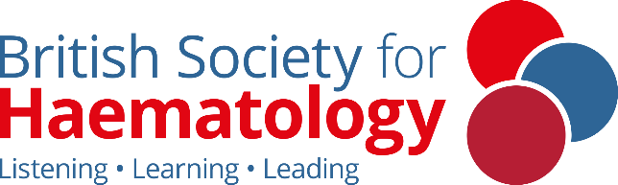

Haematology for Internal Medicine Trainees

Saturday 20 September
University of Leicester

This course supports IMT doctors in exploring and understanding Haematology clinical themes, core conditions and the training pathway. Taught in person with a focus on group work and networking, this course is suitable for resident doctors considering a career in haematology, or anyone working in healthcare seeking to deepen their understanding of haematology.

09:00 | Registration and tea and coffee
09:30 | Welcome and outline of the day
09:45 | Leukaemia and bone marrow failure – Drs. Sarah Wharin & Katherine Hodgson
10:30 | Leukaemia and bone marrow failure: break out groups
11:15 | Break: Tea/coffee
11:30 | Lymphoma and Myeloma – Drs. Sapna Ladani & Rachel Fisken
12:15 | Lymphoma and Myeloma: break out groups
13:00 | Lunch
13:45 | Red cell disorders and transfusion – Dr. Matt Player
14:30 | Red cell disorders and transfusion: break out groups
15:15 | Break: Tea/coffee
15:30 | Thrombosis and Haemostasis – Dr. Karyn Longmuir
16:15 | Thrombosis and Haemostasis: break out groups
17:00 | How to get a Haematology training number – Dr. Frances Wadelin
17:30 | Meeting close

Course fees:
£35 – BSH Members
£70 – Non Members
Book now and more information

Take a look at our free associate membership for Foundation Doctors, IMTs and Health Professionals up to Band 7

For any queries please contact education@b-s-h.org.uk

